# ****The Gap:****

There are many events happening around us on the daily basis. But there is a communication gap between the attendees and organizers. Many people would like to go and most of those even join these events. For publically announcing an event organizers and event managers use Facebook, Instagram, Twitter and other such platforms. These social platforms are not specifically for events only. Top of these platforms is Facebook. Almost every event is publically announced on it. But the issue is only those people can see the event ad who are following the page or if the page admin use boosters (which are paid) to spread the event. Means that if a page has 500 followers, so only around 500 on people would get to know about it, even if the event is worth attending and there would be thousands of others waiting for such events. So the problem is that people missed crazy and special events because they “didn’t knew” about it. There is a gap between the attendees and the organizers that’s need to be fulfilled.

# Initial POV’s:

In the very first step we did surveys and interviewed end users. We asked several question to the marketing managers, PR managers, event organizers, attendees and developers.

At first we interviewed Kabeer Afzal Khan. He is the President of the Adventure Society and leading organizer in Barsalego of FAST FSD campus.

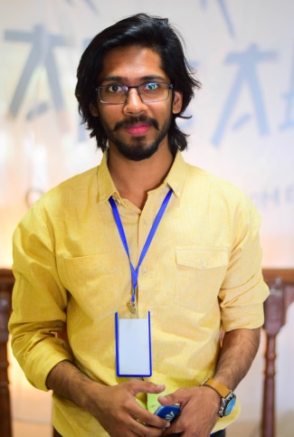

We asked the ways of marketing the Barsalego and how do they target their market. The answer was quiet familiar and it’s Facebook. They said that they have Facebook page of Barsalego with more than 1K followers through which they market their event on web. They said we share our posts on the other official and unofficial pages of all the campuses of FAST. While we were observing his facial expressions he observed that he wasn’t much satisfied with the FB marketing. About targeting the market he said that we write invitation letters to the different institutes, talk to the ambassadors and make visits to those institutes. We asked more about the response of the people. On this question he replied that the response is always good but not as good as expected. He was little disappointed by the FB figures of goings and interested. He said that our enthusiasm went down when we receives the actual audience and compares it with FB figures. They mostly receive the registration fees by hand or through Easypasia.

**POV:** Facebook is a liar and there isn’t any platform for publically announcing the event.

Secondly we talked Ahmad Islam. Mr. Islam is the program manager at Plan9 and has a very good experience in marketing the events of plan9. Plan9 is very big Government Incubator and hosts a number of events every month.

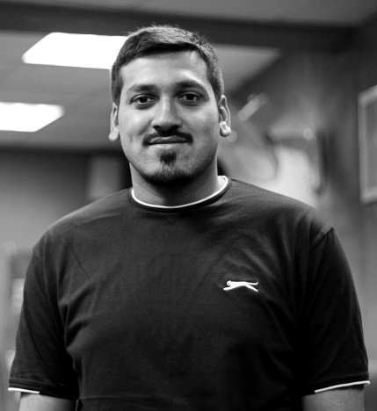

When we interviewed him we came to know that there are two types of events, planned and unplanned. The unplanned events are mostly private events and for marketing such events they don’t need any kind of social media platform. Such events are organized for specific targeted people and they can be informed by emails or phone calls. For planned events like Launchpad and start-ups expo, they do use social platforms like Facebook, Twitter and Instagram. Because they have enough followers on these platforms so they don’t need any other platform. They mostly target the Lahore so in other cities people don’t even know about the Plan9. The response of the people depends on the type of the event and the day/time for the event. On average 50% of responses we got on Facebook, people do come. Facebook is a very famous and big platform but it’s not designed for events specifically. People sometimes missed the news feeds and sometimes skip it unintentionally. We can’t target the infrequent users. If a person doesn’t uses the Facebook for 4 days and there was an event occurring near him of his interest but he doesn’t know about it because he wasn’t online for 4 days. Unfortunately he’ll miss that event. So yes there is a situation that needs to be resolved.

**POV:** infrequent Facebook user but interested person may missed the specific events.

5

# Additional need finding:

To more deeply understanding the problem we further interviewed an android application tester and developer. Mr. Zeeshan Mirza works as a senior software engineer in PITB. We inquired him both as a developer and a user.

We came to know that there are some platforms that will gives detail information about the events specifically but they are not of very good use. There UI is not very convenient and easily understandable. Moreover only 1 out of 30 people knows about those platforms. Moreover the live events on Facebook are not all the authentic. They are not verified so a person doesn’t know that either the event is secured or not. So the security is major threat.

**POV:** Security is the major issue.

We made an interview to an end-user. Zohaib Qureshi who is an enthusiast wander boy.

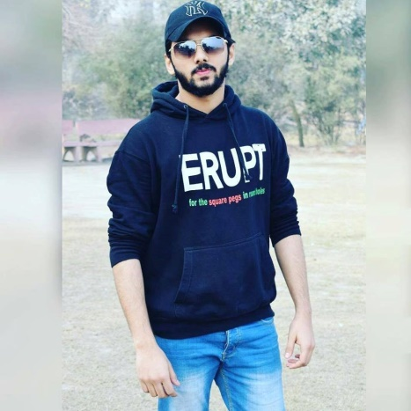

We asked him several questions about his experience. He do attends many events and mostly he came to know through the Facebook page. He followed a lot of facebook pages so any event that will happen will appear in his news feeds. When we asked to elaborate further he said that although he do know about the events yet he missed many events of his interest because he didn’t get notification. He also told one of his experiences about the cancellation of an event and didn’t get notified until he reached at the venue. He said Lahore Eat was a big event happened in Lahore and the official date was 10th to 12th of March but when he reached at the venue he c ame to know that the event has been cancelled and would be rescheduled. He said this is the most irritating thing. The same thing happened during BNU Bestival.

**POV:** Cancellation of an event is not annoying unless you get notified earlier.

**HMW’s:** After interviewing our end users we draw the following how might we’s.

1. HMW help in letting them know about the events around them
2. HMW help them to approach the events of their interest
3. HMW facilitate them in online booking and purchasing of events and tickets
4. HMW we ensure the availability of organizers
5. HMW we let the attendees know about the update in the schedule or cancellation of events
6. HMW we ensure the security of the event
7. HMW help them in preserving their time when any event is being cancelled
8. HMW help them in locating the venue of the event
9. HMW notify them even when they are offline
10. HMW increase their market by minimizing the cost
11. HMW achieve maximum audience/attendees
12. HMW ensure the almost exact number of people joining the event
13. HMW check that the event is not fake
14. HMW help to grow the local business
15. HMW target infrequent Facebook users

# 3 best HMW’s

The best of these HMW we choose are,

1. HMW ensure the maximum number of attendees
2. HMW target infrequent users of Facebook
3. HMW let the attendees know about the update in the schedule or cancellation of the event

# Solutions

The solutions we brainstormed for the above HMW’s are

1. Market the event on larger scale by adding more billboards and flyers
2. Add individuals in every institute that will let the people know about the updates
3. Increase the managing team and allow them to tell every single about the event
4. Make a call centre where people can ask about the events and their queries
5. Provide a call dictionary to the organizers through which they would make a call to everyone and tell them about the event and updates
6. Make a bus service which receives the attendees and drop them on the venue
7. Do nothing and just pray that people get revelation about the event
8. Add screens or LED’s at the rush areas of the city and run events ad so that maximum people get the information about the event
9. Hire a marketing firm and let them do their task
10. Ask people to take oath that they shall attend the event
11. Make an android application that will allow the user to find the events around them, get notifications, find events of their interest, get updates etc.

# Best Solution

**Evelander** is an android application that will solve all the problems of both organizers and attendees. Evelander is a multi-purpose app that will allow you to locate all the events happening near you. There will be different categories like sports, textile, media, arts, expos, travel, etc. You can select multiple categories of our interest. Only those events will be appeared on your home screen which you have added in your interests. You can add any of those events in your favourites or going list. The events will have a short description, includes timing, date, day and venue. A short reminder will appear on the day of the event or as you want. Secondly the event schedule and any update in the event will be done simultaneously. Cancellation of the event or any update will be provided by the online/offline text. There will be an additional option of chatting with the organizers. You can rate any event and provide your valuable reviews which will help the organizers to improve their events and remove their flaws.

